PercussionArts Switzerland
School for African, Cuban, Latin and Indian Rhythm und Percussion

Jörg Kaufmann
Wasgenring 78
CH-4055 Basel

0041 / 76 / 303 43 77
www.percussionarts.net

Maps to the School (Teachings and Shop):

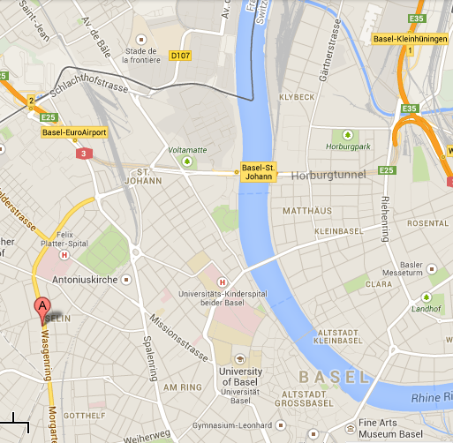

Alte Spinnerei
Fabrikstr. 28
8854 Siebnen

